INTERNSHIP REPORT
on
FIGHTER AIRCRAFT FLIGHT READINESS SYSTEM

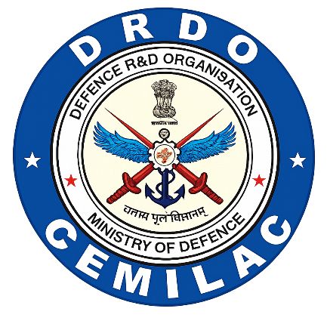

CENTER FOR MILITARY AIRWORTHINESS & CERTIFICATION
(CEMILAC)

INTERNSHIP DURATION:
5th January 2026 – 31st March 2026

SUBMITTED BY:
PRAGATHI M V [20221CBD0052]
JHENKARA CML [20221CAI0120]
SHWETHA B [20221CCS0146]
PRESIDENCY UNIVERSITY, Bengaluru.
GUIDED BY:
Shri SANYASI RAO RUPITI, Sc ‘E’
RCMA (APS),
CEMILAC, Bengaluru.

